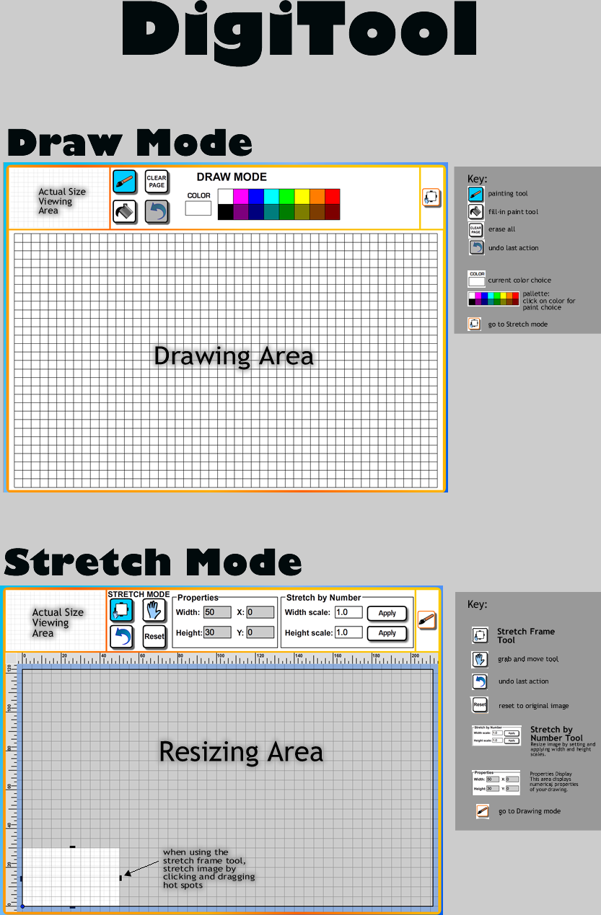
To launch the DigiTool digital drawing tool:
- Open the DigiTool folder (design_the_mascot/content/DigiTool)
- Double-click on the file “start_digitool”
- Click on the “Start” button
In Internet Explorer, you may have to click on the yellow warning bar and choose “allow blocked content”.

Inserting pictures into Word or Powerpoint (PC):
If you are writing a report in Word or in Powerpoint, you can take a screenshot:

- Make sure the window showing the DigiTool software is selected (click on the title bar).
- Hold down the Alt key and press the Print Screen (or Prt Sc) key. Release the Alt key.
- Switch to your word processor
- Do Edit -> Paste (or Ctrl-V) - this should paste a copy of the DigiTool software window into your Word document,

Optional: In Microsoft Office you can use the Crop tool to make the result look better - click on the picture you have just pasted in, choose the “Crop” tool from the picture toolbar, then drag the handles on each side of the picture to hide the bits of the image you don’t want.

